All Round Performance Pony

Rules:

1. Open to CSHPC members only.

2. One Card must be entered for each pony & rider/driver combination.

3. Points are awarded for placing in any competitive event excluding in hand from 1st January 2016 to 31st December 2018

4. Points will be awarded as follows:

1st 6 points
2nd 5 points
3rd 4 points
4th 3 points
5th 2 points
6th 1 point

Champion 10 points
Reserve 5 points

No extra points are awarded for Supreme Champion

Double points are awarded at the CSHPC Spring Show, The Royal Highland Show and CSHPC Summer Show.

5. For this section points are awarded for being placed in any competitive discipline other than in hand and is not restricted to HPS affiliated events.

Rosettes for All who take part.

Good luck to you all!
We look forward to receiving your completed card back.

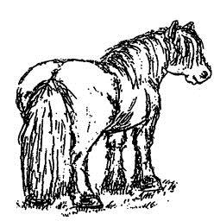
Central Scotland Highland Pony Club

CSHPC All Round Performance Card 2018

Member Name: _________________________________________

Pony Name: ____________________________________________

** One card per pony – download more from www.cshpc.co.uk **

www.cshpc.co.uk

Date | Event | Class | Placing | Official Use
Date | Event | Class | Placing | Official Use

