Rules:

1. Open to CSHPC members only.

2. One Card must be entered for each pony & rider combination.

3. Points are awarded for CHPC Events only.

4. Points will be awarded as follows:

Attending Training | 12 points.
Entering a class at a show | 5 points.
Entering One Day Event | 8 points.
Points for Placings:  I.e. entering a class at the summer show, and coming 4th would gain you 8 points. 5 for your entry, and 3 for your placing.  (Applies to all classes at shows and the overall event only) | 1st | 6 points.
 | 2nd | 5 points.
 | 3rd | 4 points.
 | 4th | 3 points.
 | 5th | 2 points.
 | 6th | 1 points.
Attending a Ride Out | 10 points.
Unmounted Events  AGM, stud visit, or social event. | 4 points.

5. In the case where a member has entered more than one rider/pony combination, social event points may be applied to one card only. It is the members decision which card to apply these points to.

The winner will receive their next years membership free!

Good luck to you all!
We look forward to receiving your completed card back.

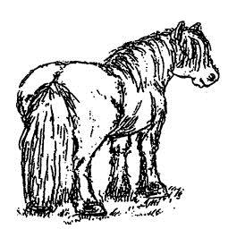
Central Scotland Highland Pony Club

Club Pony of The Year
Performance Card 2018

Member Name: _________________________________________

Pony Name: ____________________________________________

** One card per pony – download more from www.cshpc.co.uk **

www.cshpc.co.uk

Date | Event | Class | Placing | Official Use
Date | Event | Class | Placing | Official Use

