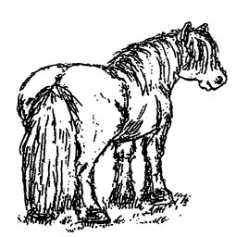

Central Scotland Highland Pony Club

Notification of Annual General Meeting 2015

The Annual General Meeting of the Central Scotland Highland Pony Club, will be held at Strathallan Castle, Auchterarder, PH3 1JZ on Friday 6th March at 7.30pm.

AGENDA

- Welcome and apologies
- Minutes of the AGM held on 21st March 2014
- Matters arising from the minutes
- Chairperson's Report
- Treasurer's Report
- Election of Office Bearers
- Election of Committee Members
- Programme of Events 2015
- Any Other Competent Business
- Close of AGM

The AGM will be followed by the presentation of the Performance Awards for 2014 – please email cards in prior to the AGM. If you require another card, these can be downloaded from the website www.cshpc.co.uk
Email to: info.cshpc@gmail.com

We have a number of vacancies on committee for 2015. If you are interested, or would like to nominate someone please contact Rachael or fill in the below form and hand it in before the start of the AGM.

Stovies (veggie option available) plus teas and coffees will be available after the meeting, which we hope you will be able to stay for. Please can you let Rachael know if you attend to come along so we can confirm numbers for food. rach.e.stewart@gmail.com or 07793219006.

Election of Committee Members/Office Bearers

Nomination form for use when nominee/proposer/seconder are unable to attend the AGM.

To be in the hands of the Chairperson by the time the AGM starts

Name Of Nominee: |  | Signature:
Appointment:
Proposed by (Name): |  | Signature:
Seconded by (Name): |  | Signature:

